 Data Use & Publications Policy

Publications refer to the following: abstracts/posters, manuscripts, presentations and/or data requests for grant submissions.

Section I
Purpose
The intent of this document is to outline the steps needed for requesting use of HMS data; this includes data requests for internal HMS quality improvement (QI) program evaluation or research publications.

Process for Use of Individual Site Data:
- Each participating hospital may use their own data for internal purposes or for publication acknowledging that the data was obtained via participation in HMS.
- If a participating hospital uses their own HMS data for publication or presentation – using their own analyst resources – and wishes to utilize the HMS logo or referencing that the project utilized HMS data, please send the final manuscript to jenhorow@med.umich.edu at least two weeks prior to submission. (Please see Requirements for HMS & BCBSM Acknowledgements below for information on proper attribution).
- If a participating hospital would like to use their own HMS data for publication and requires the assistance of a Coordinating Center Statistician, the data must be requested using the HMS Analytic Memo (see below) and the HMS Coordinating Center will need to provide approval.
- Participating hospitals must agree to uphold the collaborative nature of HMS and refrain from using HMS data to compare itself to other consortium members in any public manner including presentations, publications, publicity, and/or advertising. Please note, anonymous cross hospital comparison is allowable for the purpose of discussing variation and should be done in a collegial and constructive manner.

Process for Request for Use of Consortium-Wide Data:
- Complete the HMS Analytic Memo. This form is available on the HMS website. Additional materials are also on the website to support the completion of this form, including all relevant data dictionaries, a sample analytic memo and a list of the questions contained in the analytic memo.
- To assist with understanding of data structure and available data variables, an HMS Coordinating Center staff member will offer the option to meet with the original requestor 1:1. Additionally, primary, and senior authorship must be determined.
- Upon receipt of the HMS Analytic Memo, an HMS Coordinating Center data analyst/statistician will confirm the inclusion and exclusion criteria for the cohort requested. Information on the size of the cohort will be sent to the original requestor for final decision on whether to continue with the data request or identify modifications to the analytical plan. Once the cohort is confirmed, the request will be communicated with the HMS Physician Project lead for awareness. The request will be added to the agenda for an upcoming HMS Data, Design, & Publications (DDP) meeting. Approval by the DDP will be made by majority vote. Please note, if no formal DDP meeting is conducted, publication approval may be obtained via email correspondence with the members of the DDP. This e-mail will be sent by the HMS Coordinating Center.
- The requestor should be prepared to present a summary of the data and to field questions related to the data request or publication at the scheduled DDP meeting. To facilitate this conversation, the requestor should prepare a series of PPT slides; the HMS Coordinating Center has a template for these slides available. Additionally, the members of the DDP will be given an opportunity to participate in the publication and should notify the HMS Program Manager of desired participation.
- Upon completion of the DDP meeting, the HMS Coordinating Center staff will notify the requestor of the DDP decision. They will also notify the requestor of any DDP members that would like to engage in the research process.
- The HMS Program Manager will determine staff availability and identify project team:
  - Statistician – conduct the analysis
  - Quality Coordinator – answer questions related to data variables, sampling procedure, etc.
  - Project Manager – facilitate logistics, manage tasks, and keep team on track, and assist with appendices
- If multiple competing priorities will delay the completion of the data request, the request will be assessed as follows:
  - High – Aligns closely with current HMS priorities with high potential for impact on QI activities. These items may align with collaborative meeting topics as well.
  - Moderate – Aligns or builds on current HMS priorities with growth opportunities within existing initiatives and/or for new QI activities.
  - Low – Little to no alignment with current HMS priorities with little potential for QI work; research-based only
- After identification and availability of staff is confirmed, the HMS statistician will complete a timeline for analysis completion and send to the original requestor. Additionally, the HMS statistician will complete the data request via the specifics from the analytic memo. Once complete, the statistician will distribute the results electronically via an encrypted, and/or password-protected format to the original requestor and notify the project manager to set up a meeting with the original requestor, HMS project team, and additional co-authors.
  - Note: To be considered for co-authorship, the co-authors must participate in the study on an ongoing basis, including communicating with the project team via email and/or attendance at project meetings. Also, please refer to the HMS Guidelines for Authorship for Publications for more details on how authors will be determined.
- Prior to submission for publication, the final analysis may be shared with the DDP to keep them apprised of the work. No additional co-authors will be allowed at this time. The requestor will be advised to present a series of slides to use at the scheduled DDP meeting. If no formal DDP meeting is conducted, the project update will be made via email correspondence sent the members of the DDP by the HMS Coordinating Center.
Additional Notes:
- The analysis and manuscript preparation for submission to a peer-reviewed journal is expected to be completed within 12 months of receipt of data.
- Requestors are expected to be actively engaged throughout the research process and should be available to review and provide feedback on materials sent to them by the coordinating center within two weeks of receipt.
- Individuals from any HMS participating hospital can submit a concept to the HMS Coordinating Center, who will review the request based on the guidelines outlined above.
- If an individual requestor has multiple data requests in process at a given time, the HMS Coordinating Center may factor this into approval of subsequent data requests and is dependent on Collaborative priorities and available resources.
- Depending on alignment of requested data with HMS strategic initiatives, the HMS Coordinating Center may request that you present the data at an upcoming collaborative wide meeting or webinar.

Prior to Submission for Publication
- Any drafts and subsequent final version must be reviewed and approved by the following:
  - All Publications: Dr. Scott Flanders & Elizabeth McLaughlin
  - PICC/Midline Publications: Dr. David Paje
  - Antimicrobial Publications: Dr. Tejal Gandhi
  - Sepsis: Dr. Hallie Prescott
  - Critical Care: Dr. Liz Viglianti, Dr. Paul Bozyk, or Pat Posa
- The above individuals must be given at least 2 weeks to review the publication and provide feedback.
- If you are requesting data for a publication that is attached to a submission deadline, we recommend submitting your concept within 3 months of your deadline (urgent requests will be reviewed on a case-by-case basis).
- As of December 2023, BCBSM is requesting to review select publications in advance of submission. The HMS Program Manager will assist in determining which publications need to be routed to BCBSM.
  - Types of articles DO NOT need to be submitted prior to submission for publication
    - Articles focused only on clinical work and clinical findings
    - Articles in which the only mention of Blue Cross is the acknowledgement of our support and disclaimer statement
  - Types of articles MUST be submitted prior to submission for publication as they could reflect
negatively on Blue Cross
- Articles that mention Blue Cross incentives (e.g., P4P or VBR) or Blue Cross programs (e.g., Centers of Excellence, Blue Distinction Centers, value-based contracting)
- Articles that mention funding of the program (e.g., coordinating center and FTE support) beyond the standard acknowledgement
- Articles that mention the administrative operations of the CQI program
- Article that evaluate costs related to the program and/or clinical condition
- Articles that mention Blue Cross medical policies or benefits

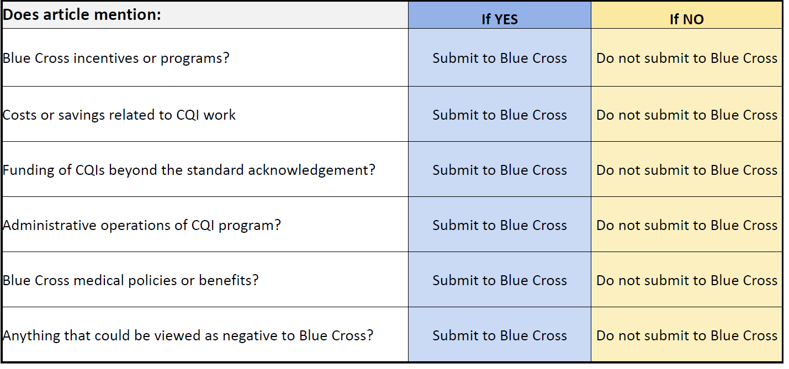

HMS Branding Guidelines

Poster Presentations, Slide Presentations, Visual Abstracts
- Individuals using solely HMS CQI data must use the HMS template that includes the HMS logo and BCBSM logo. This template can also include your institutions logo.
  - Exception – If the poster is being presented at a conference and you must use its poster template, the HMS and BCBSM logos must be incorporated.
- Individuals using data gathered from sources outside of HMS along with HMS CQI data may use a template at their personal discretion, however, the HMS logo must be incorporated.

Social Media
- Individuals highlighting work on social media using solely HMS CQI data should tag the HMS CQI account on either X, Bluesky, or LinkedIn. Please use the handles:
  - X platform - @HMS_MI
  - Bluesky - @hms-mi.bsky.social
  - LinkedIn - https://www.linkedin.com/company/mi-hms
HMS Templates
- Please reach out to Jennifer Horowitz (jenhorow@med.umich.edu) if you need a poster/presentation template. If available, please share specifics on poster sizing requirements.

Requirements for HMS & BCBSM Acknowledgements
- For an abstract or manuscript: HMS and BCBSM should be acknowledged as the source of information in materials presented and/or published with the following statement:
“This (study or project) included data from the Michigan Hospital Medicine Safety (HMS) Consortium which is a statewide quality improvement collaborative to improve the quality of care for hospitalized medical patients. Support for HMS is provided by Blue Cross Blue Shield of Michigan and Blue Care Network as part of the BCBSM Value Partnerships program; however, the opinions, beliefs, and viewpoints expressed by the author do not necessarily reflect those of BCBSM or any of its employees.” If there are word count limitations the underlined statement above is the minimum wording necessary.
- Note: this includes abstracts or manuscripts describing site specific work/data if there is mention of HMS.

Section II
Purpose
The intent of this document is to outline the steps needed for external HMS data requests (i.e. outside of the Coordinating Center) including; sharing of data sets during the publication process to verify the reproducibility and integrity of the data source, and sharing of data sets with statisticians/methodologists outside of the Coordinating Center to allow for additional complex modeling or assistance with time sensitive analyses that is critical for the Collaborative quality improvement goals.

Process for Request for Use of Consortium-Wide Data by Journals during the Publication Process for Verification:
- The lead author and/or statistician should e-mail requests for data to Jennifer Horowitz (jenhorow@med.umich.edu). She will work with you to understand the minimal data necessary to develop the dataset.
- Upon receipt a data analyst will complete the data request via the specifics noted in the form. All data shared is aggregated at the Collaborative level. Under no circumstance is individual hospital level data shared outside of the Coordinating Center.

- Once the data set is confirmed, the request will be communicated with the HMS Physician Project lead for awareness. The request will be added to the agenda for an upcoming HMS Data, Design, & Publications (DDP) meeting. Approval by the DDP will be made by majority vote. Please note, if no formal DDP meeting is conducted, publication approval may be obtained via email correspondence with the members of the DDP. This e-mail will be sent by the HMS Coordinating Center.
- If approved by the DDP, the analyst will distribute or save the limited de identified data set via an encrypted, and/or password-protected format to the lead author for submission to the Journal via the requested repository.

Process for Request for Use of Consortium-Wide Data to allow a Statistician/Content Expert/Methodologist outside of Coordinating Center Staff to complete analyses:
- Upon identification of the need to involve an expert outside of the Coordinating Center to complete an analysis using HMS Collaborative Wide Data the HMS Project Manager will add the request to the agenda for an upcoming HMS Data, Design, & Publications (DDP) meeting. Approval by the DDP will be made by majority vote. Please note, if no formal DDP meeting is conducted, approval may be obtained via email correspondence with the members of the DDP. This e-mail will be sent by the HMS Coordinating Center.
- If approved by the DDP, an HMS Coordinating Center analyst or statistician will develop the data set including the minimal data necessary to complete the analysis. In addition, the analyst, statistician and/or other Coordinating Center staff will provide data definitions, sampling strategy and data dictionary to assist with understanding of the general structure of the data.
- If the statistician/content expert/methodologist is external to the University of Michigan an Unfunded Agreement is required and they must complete and sign a data use agreement.
- Once the dataset is confirmed and the data use agreement with the expert has been completed, the analyst will distribute or save the limited de identified data set via an encrypted, and/or password-protected format to the external expert for analysis.

**This policy does not apply to press releases and interviews. All requests for press releases and interviews regarding HMS will be handled by the HMS Coordinating Center.

