Care of the Midline in the Home

What is a midline?
A midline is a small, flexible tube inserted into a vein in your arm. The midline is approximately 6-8 inches long, but trimmed so the tip of the midline rests inside a vein at or below your armpit.

Why are midlines used?
A midline is used to give medications or fluids through a vein. Midlines can stay in place for several weeks and can meet short term intravenous requirements at home.

How is a midline inserted?
The midline will be inserted at your bedside or in a radiology department and should take about 30-60 minutes. A nurse or other clinician will insert the midline and thread it into a large vein in your upper arm.

What is a lumen?
The word lumen means the opening or path that is inside the midline. It is through this opening that you give medications through your vein.

HomeMed

How will I care for the catheter?
There are several things you will need to know in order to care for your midline. Below are the steps you must take to prevent infection and ensure it will continue to work well for as long as you need it:
- Properly store, check and handle supplies.
- Select and prepare a work area.
- Clean your hands.
- Flush your catheter with heparin every 12 hours.
- Attach new alcohol cap after every heparin flush.
- Have your dressing changed regularly.
- Have your catheter cap changed weekly.
This booklet details these skills, then lists ways you can protect your catheter and includes a table for troubleshooting problems that can happen. Your nurse will make sure you understand the procedures and provide time for you and your family to practice.

Storing Your Supplies
- Keep items away from children and pets.
- Store supplies in an area that is dry and free from dirt, dust, and clutter.
- Choose a place as close to your work area as possible.

Checking Your Supplies
Check your syringes and do not use if:
- Leaks are present.
- Fluid is cloudy or discolored.
- Particles or specks appear in the fluid.
- It has expired.
Check all packaging and do not use if:
- Seal is broken.
- Package is torn.
- Any part of the package is wet.

Selecting Your Work Area
Work on a table, laminate mat, counter top, or tray that can be cleaned with a household disinfectant or rubbing alcohol in an area:
  - Free from drafts, dirt, dust, and clutter.
  - With enough space and good lighting.
  - Near your supplies.
Do not work in the bathroom since most of the germs in your house are located there. Also, avoid working in your kitchen where you prepare food.

Preparing Your Work Area
- Place a trash can next to your work area.
- Clean your work surface or laminate mat with household disinfectant or rubbing alcohol. Let the area air dry.

Cleaning Your Hands
Although your hands may look and feel clean, it is always important to wash your hands in order to remove germs you can’t see. Your hands should always be washed before any midline care. You must wash your hands again if you touch anything that might be considered dirty.
There are two ways to properly clean your hands: Washing with soap or using an instant hand sanitizer (containing 60-90% ethyl alcohol). If your hands are visibly dirty or you have a C. difficile infection, you must wash your hands with soap and water.

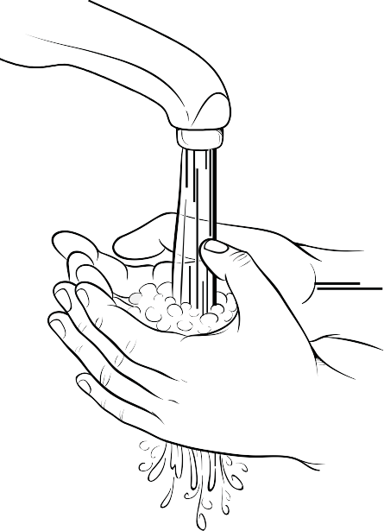
Washing Your Hands with Soap
- Wet your hands and wrists under warm running water.
- Apply soap and scrub vigorously for 15 seconds.
- Work lather between fingers, under nails, over the palms and back of your hands.
- Rinse your hands well. Make sure to keep your hands up so the dirty water runs toward your elbows.
- Dry your hands with a clean paper or cloth towel.
- Turn off the faucet with a clean towel.

Using an Instant Hand Sanitizer
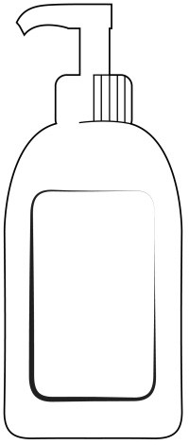
- Place a dime-size amount of instant hand sanitizer in one hand.
- Gently rub the gel into palms and backside of hands and between fingers.
- Allow your hands to air dry.

Handling Sterile Supplies
  - Some of the supplies are sterile. Sterile means that all germs have been removed by a special cleaning process.
  - Parts of supplies that must be kept sterile are protected with a cover.
  - Never touch sterile parts with your hands or allow a sterile item to touch a non-sterile surface.

Flushing your midline
Your midline lumen must be flushed to prevent infection and keep blood from clotting. Flush twice a day with heparin if not in use.
Supply list:
- Prefilled heparin flush syringe (10 units/mL)
o removed from package
- Alcohol pads
- Alcohol cap

Key Points
- The heparin syringes do not need to be refrigerated.
- Do not use force when flushing your catheter. If you cannot flush your catheter easily, call your clinician.
- Check your IV catheter cap to make sure it is attached securely to your catheter (always hold your catheter cap while connecting/disconnecting syringes to prevent accidental removal).
- Never reuse a syringe.

Follow these steps when flushing your midline:
- Place a trash can next to your work area and clean your work surface.
- Wash hands with soap for 15 seconds or use an instant hand sanitizer.
- Gather your supplies and place on your clean work surface.
- Remove alcohol cap from your IV catheter cap.
- Open an alcohol pad and vigorously scrub the end of the cap on your catheter for 15 seconds and allow the alcohol to dry. Do not fan or blow on it. Do not place the lumen down or contaminate the end of the cap.
- Do not remove the cap from the prefilled syringe and press forward on the plunger to break the seal. Do not pull back on the plunger.
- While holding the syringe upright, gently tap the sides of the syringe so the bubbles rise to the top. Remove the cap and push the plunger to remove all

the air. Push and twist the heparin syringe into your catheter cap to the right until secure.
- Unclamp your catheter.
- Push the heparin flush solution into your catheter until 0.5 ml remains in the syringe. Clamp your midline, remove the syringe and discard in your trash.
- Attach new alcohol cap onto end of your IV catheter cap.

Changing the midline dressing
Supply list:
- IV Dressing Change Kit
  - Sterile drape
  - Sterile gloves
  - Skin protectant pad
  - ChloraPrep®
  - Gauze sponge
  - Mask
- Securement Device (i.e., Grip-Lok®)
- IV Dressing

Key Points
- Clean the skin and change the dressing 3 times a week for gauze and tape
dressing (such as Monday, Wednesday and Friday).
- Clean the skin and change the dressing every 7 days if you have a clear
dressing.
- Change the dressing as soon as possible if it becomes dirty, wet or loose.
- Never use scissors near the midline.
- Do not pull, bend or kink the midline.

Follow these steps for changing the dressing:
  - Place a trash can next to your work area and clean your work surface.
  - Wash your hands with soap for 15 seconds or use an instant hand sanitizer.
  - Gather your supplies and place on your work surface.
    - Open the dressing kit.
    - Put on the mask.
    - Remove the sterile drape.
    - Open the drape and place on your clean work surface.
    - Place contents of the kit on the sterile drape.

  - Carefully remove the old dressing:
    - Pull the dressing one corner at a time toward the catheter exit site.
    - After all the corners are loosened, hold the catheter down and pull the dressing up and off. Do not touch the area surrounding the insertion site while the dressing is off.
  - Throw the old dressing away and clean your hands again with an instant hand sanitizer.
  - Look around the midline insertion site and surrounding area for swelling, redness, tenderness or drainage. These could be signs of an infection. If present, call your clinician after finishing the dressing change procedure.
  - Put on sterile gloves.
  - Remove the cleansing swabstick from the package.
  - Carefully clean around the midline:
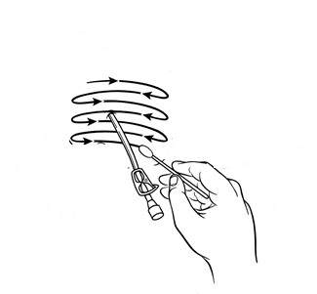
    - Use a back-and-forth motion for 30 seconds.
    - Completely clean at least 2 inches around the midline exit site.
    - Allow the area to air-dry completely. Do not blot or wipe dry.
    - Discard the swabstick.
- Clean the area again with the remaining swabsticks,
discarding after each use and allowing the solution to dry.
  - Apply the skin prep to the area around the catheter insertion site, starting 1 inch away from the catheter and working outward. Let dry until smooth and shiny. Always wait until the area is completely dry before proceeding to the next step.
  - Apply the new dressing:
    - Remove the protective backing from the dressing.

    - Apply dressing over the exit site by placing the center of the transparent window over the catheter exit site.
    - Slowly remove the frame on the dressing while smoothing down the dressing edges.
    - Take one adhesive strip from the frame of the dressing and crisscross or “butterfly” it around the catheter and attach it over the dressing.
    - 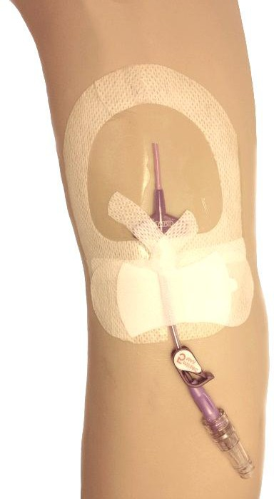Place the other adhesive strip over the butterfly to hold it in place.

Adhesive strips
Securement device

  - 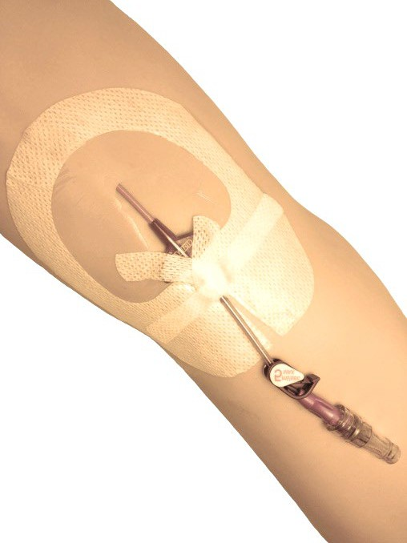Apply the securement device (i.e., Grip-lok®):
- Peel the paper backing from the securement device and place under the catheter on the split area of the midline dressing.
- Lift the top flap and remove the paper backing where it says “peel”.
- Place catheter tubing on top of the bottom strip of the securement device.
- Place top flap over the tubing so that the tubing is secured between bottom strip and top flap.

Changing the midline catheter cap
Supply list:
- IV catheter cap (needleless connector)
- Alcohol pads

Key Point
- Change cap every 7 days.

Follow these steps for changing the cap:
- Place a trash can next to your work area and clean your work surface.
- Wash hands with soap for 15 seconds or use instant hand sanitizer.
- Gather supplies and place on your work surface.
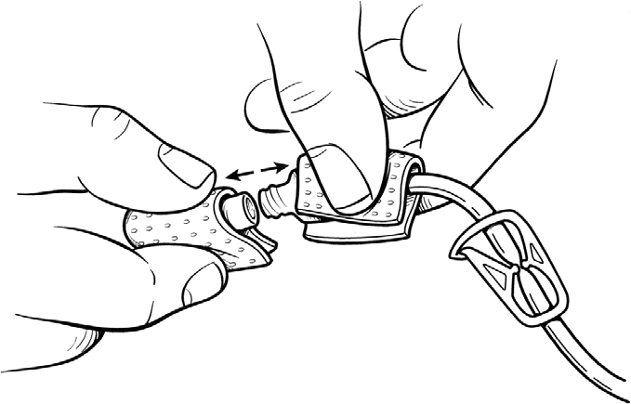
- Open the sterile catheter cap package carefully and leave the cap in the package without touching it.
- Check that the midline is clamped.
- While holding the midline lumen with an alcohol pad in one hand, vigorously clean the catheter/cap connection with a second alcohol pad for 15 seconds.
- Carefully remove the midline cap and throw it away. If you cannot get the cap off, try using rubber gloves or tape to get a better grip. Do not use pliers. Once the cap is off, be very careful not to touch the open end of the midline or place the lumen down.
- While holding the lumen in one hand, remove the new cap from the package with your other hand. Unscrew the protective covering from the new midline cap making sure that you do not touch the open end of the new cap.
- Screw on the new cap.

How will I protect the catheter?
You may participate in most normal activities including work, school and exercise. The following precautions will help prevent damage and infection:
  - Avoid swimming, use of hot tubs or any activities that may get any part of your midline wet.
  - Keep the dressing and catheter clean and dry when you shower or bathe.
    - Cover the dressing and catheter with plastic and tape the edges of the plastic onto your skin.
    - If the dressing gets wet, change the dressing as soon as possible.
    - Never let the catheter end get wet.
  - Avoid golfing, bowling, weight lifting, archery or activities requiring vigorous or repetitive motion of the arms.
  - Avoid any contact sports where the catheter might be pulled or grabbed.
  - Limit any activity such as pulling, pushing, or lifting.
  - Use caution when walking with crutches.
If you have any questions about activities while your midline is in place, please contact your clinician.

Troubleshooting midline problems
Problem | Possible cause | What to do
Infection
- Fever and/or chills.  - Redness, swelling, tenderness, and/or drainage at the exit site. | - Infection in or around the midline or in your bloodstream. | - Call your clinician immediately.  - If pus or drainage is present, note the color, odor, and amount. Give this information to your  clinician.
Midline damage
- Break  - Puncture | - Repeated clamping, excessive pulling the midline, or contact with a sharp object.  - Rupture from attempt to flush a blocked midline: higher risk when using small  syringes. | - Clamp your midline above the damaged area. This will prevent bleeding and keep air from entering the midline.  - Call your clinician immediately.
Blocked midline
- Cannot flush.  - Cannot infuse medication. | - Midline is clamped, kinked, curled, clotted, or positioned against  the wall of your vein. | - Visually check the midline for kinks and make sure that the  midline is unclamped.

- Move your arms, shoulders, and head to see if a change in position helps.
- If still unable to flush the midline, call your
clinician.
Movement of the midline
- Length of exposed line is increased. | - Catheter is flexible and in rare cases may move out of position. | - Call your clinician immediately.

Troubleshooting Midline Problems
Problem | Possible Cause | What to Do
Midline Comes out of body
- Midline comes out of the body. | - Excessive pulling on midline. | - Immediately apply pressure over the midline site to stop any bleeding.  - Call your clinician  immediately.
Thrombosis
- Arm with midline becomes swollen and cool to the touch. | - Blood clot | - Call your clinician immediately.
Skin Irritation
- Redness  - Tenderness  - Blistering of the skin. | - Irritation from the dressing or tape. | - Call your clinician  o You may need to use another type of dressing and try to avoid placing the dressing over  irritated skin.
Fluid Leakage or Blood Back-up
- Fluid leakage from:  - End of the midline  - Along the midline  - Blood seen in midline. | - Connection between the midline and cap is loose or disconnected. | - Check midline and cap connection. Be sure they are tight.

 | - Midline is damaged from a puncture or rupture. | - Flush midline and observe exit site for signs of fluid leakage. Notify your clinician.  - Check for midline damage. If found, clamp the midline above the damaged area and call your  clinician immediately.




{Hospital Logo}

Support for HMS is provided by Blue Cross and Blue Shield of Michigan and Blue Care Network as part of the BCBSM Value Partnerships program. Although Blue Cross Blue Shield of Michigan and HMS work collaboratively, the opinions, beliefs and viewpoints expressed by the author do not necessarily reflect the opinions, beliefs and viewpoints of BCBSM or any of its employees.

Disclaimer: This document contains information and/or instructional materials developed by the Michigan Medicine for the typical patient with your condition. It may include links to online content that was not created by Michigan Medicine and for which Michigan Medicine does not assume responsibility. It does not replace medical advice from your health care provider because your experience may differ from that of the typical patient.
Talk to your health care provider if you have any questions about this document, your condition or your treatment plan.

Author: HomeMed Patient Education Committee
Patient Education by Michigan Medicine is licensed under a Creative Commons Attribution- NonCommercial-ShareAlike 3.0 Unported License. Last Revised 9/2021

